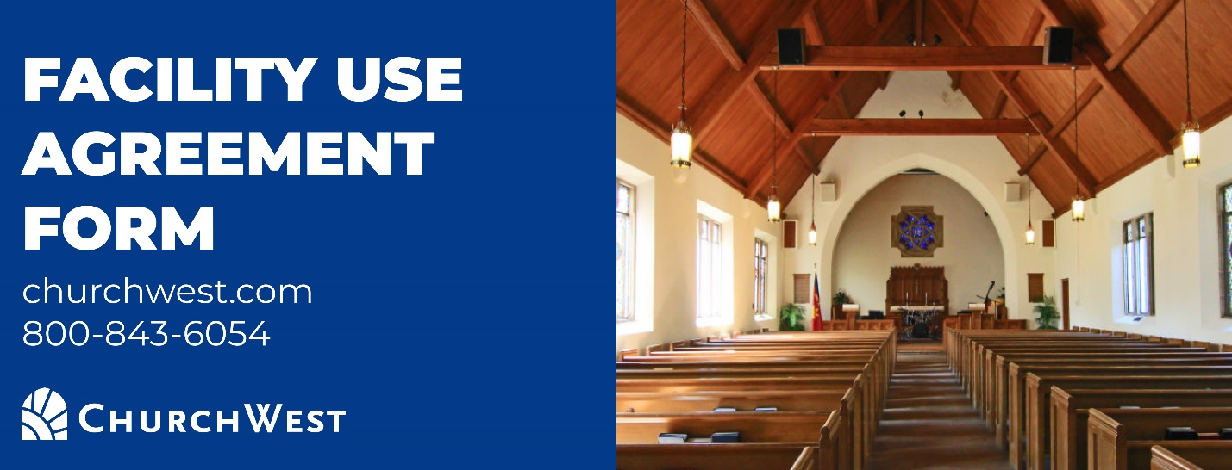

How to use this document: This document is a sample Facility Use Agreement created by ChurchWest Insurance Services. This document’s purpose is to aid your ministry when sharing the use of your facilities with third parties. We have updated this form to improve compliance with mandated reporting legislation.

- Step 1: This document should be edited by your ministry and saved internally. Lines in red should be edited using your preferred document editor (Word, Pages, Google Docs).
- Step 2: To save paper, print the edited document starting on page 2 using your print dialogue box, or delete the content of this page.
- Step 3: Both your ministry and the facility user should sign the black lines, and finally scan the completed document to your computer.

A note about this sample policy. ChurchWest is providing this resource to help your ministry stay protected and improve compliance with mandated reporter legislation. This should not be disseminated to those outside of your ministry via email or shared in any way. Any ministry that would like a copy may download from ChurchWest.com and will then receive additional legal and practical updates on California requirements. This template is a resource for your ministry, but the final version MUST be reviewed by qualified legal counsel.

FACILITY USE AGREEMENT

This agreement by and between _______________(“Owner”), and ________________(“User”), will take effect on ____________________ and will continue for a period of __________________ WHEREAS, Owner owns premises located at ____________________which is normally used for_________________ , and WHEREAS, User desires to use the ____________________area of the facilities for the purpose of ____________________ , and WHEREAS, Owner has agreed to allow User to use the facilities provided that the following terms and conditions are met.

IT IS THEREFORE AGREED BY AND BETWEEN THE PARTIES:

- Owner agrees to let User use the above described premises for the above described purpose on ___________________ . ____________________ is the contact person for Owner and is the contact person for User to coordinate the details of usage.
- Fee Agreement. User agrees to pay Owner ____________________for the use of the premises. User agrees to abide by all the terms and conditions of use described in this agreement.
- User agrees that it will not use the premises for any unlawful purposes, and will obey all laws, rules, and regulations of all governmental authorities while using the above-described facilities.
- User agrees that it will not use the premises for any purpose that is contrary to the mission, purpose or belief of the Owner, which is a biblically-based religious institution.
- User agrees to abide by any rules or regulations for the use of the premises that are attached to this agreement.
- User agrees that it is solely responsible to implement appropriate screening and supervision procedures to protect children, youth, and vulnerable adults attending user’s function at the above-described facilities.
- Organizational Users: User promises and warrants that it carries liability insurance with a minimum liability occurrence limit of $1,000,000. The User will provide a certificate of insurance to the Owner at least seven days prior to the date upon which the User begins to use the above-described premises. The certificate of insurance will indicate that User has made Owner an “additional insured” on User’s policy with respect to the use by User of the above-described premises.
Individual Users: User promises and warrants that User will obtain signed Activity Participation Agreements (either provided by or acceptable to Owner) from each participant in the activity. If the participants are minors, User will obtain the signature of at least one parent or legal guardian on each Activity Participation Agreement.
- User agrees to hold harmless, indemnify and defend Owner (including Owner’s agents, employees, and representatives) from any and all liability for injury or damage including, but not limited to, illness, exposure to infectious/ communicable disease, bodily injury, personal injury, emotional injury, or property damage which may result from any person using the above described premises, its entrances and exits, and surrounding areas, for User’s purposes, regardless of whether such injury or damage results from the negligence of the Owner (including Owner’s agents, employees and representatives) or otherwise.
- User agrees to be responsible for preparing for use and returning to the pre-use condition all areas of the premises which User will use, including entrances and exits.
- User agrees to conduct a visual inspection of the premises, including entrances and exits, prior to each use, and warrants that the premises will be used only if it is in a safe condition.
- This agreement may be cancelled unilaterally by either party with 14 days written notice to the other party. In the event that Owner must cancel this agreement, User will be entitled to any deposit User has paid. However, in no event will Owner be liable to User for any lost profits or incidental, indirect, special, or consequential damages arising out of User’s inability to use the above-described premises, even if Owner has been advised of the possibility of such damages.
- User agrees that it will not assign any of its rights under this agreement, and any such assignment will void this agreement at the sole option of the Owner.
- Owner and User agree that any disputes arising under this agreement will be resolved via a mutually acceptable alternative dispute resolution process. If Owner and User cannot mutually agree upon such a process, the dispute will be submitted to a three-member arbitration panel of the American Arbitration Association for final resolution.
- This document contains the entire agreement of the parties and supersedes all prior written or oral agreements relating to the subject matter.

OWNER
Name:_______________________
Date:________________________
Title:________________________
Signature:____________________

USER
Name:______________________
Date:________________________
Title:________________________
Signature:____________________

Affirmation that California regulations are being followed by the organization using facility:
Per California statutes, effective January 1st, 2022, all organizations in California that supervise youth are required to have the following in place:
- All volunteers who supervise youth AND employees must have background checks completed using LiveScan.
- All volunteers who supervise youth AND employees must complete training in the identification & reporting of abuse & neglect.
- Written policies and procedures for reporting suspected abuse and/or neglect outside the organization.
- Policy where all youth activities are supervised by at least two trained and screened mandated reporters.
______ Initial here that user acknowledges that the above screening, training, policies & procedures are in place by the user’s organization.

Additional information may be found at www.churchwest.com/ab506 relating to these requirements for organizations in California that serve youth.

