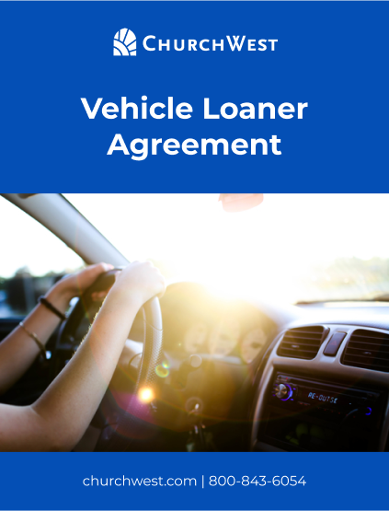

Vehicle Loaner Agreement for [MINISTRY]

This agreement is made between [Ministry Name] and the individual borrowing the vehicle, hereafter referred to as "Borrower."

1. Insurance Coverage: Borrower must provide proof of insurance coverage before borrowing the vehicle. The Ministry's insurance coverage does not extend to the Borrower. Borrower's insurance will be primary for protecting the Borrower in case of an accident.

2. Nonowner Car Insurance: If Borrower does not have insurance coverage, they must purchase Nonowner car insurance before borrowing the vehicle. This type of policy provides liability coverage for drivers who do not own a vehicle and can be purchased easily and affordably online. The Ministry recommends the following 5 places to purchase Nonowner car insurance:

- GEICO
- State Farm
- Nationwide
- Allstate
- Progressive

3. Restrictions: Borrower must comply with all federal, state, and local laws, as well as any restrictions set forth by the Ministry.

4. Damage or Loss: Borrower is responsible for any damage or loss that occurs to the vehicle while in their possession. Borrower must immediately report any damage or loss to the Ministry.

5. Return of Vehicle: Borrower must return the vehicle in the same condition as it was when borrowed, including the same level of fuel. Borrower must return the vehicle at the agreed-upon time and location.

By signing below, the Borrower acknowledges and agrees to the terms of this Vehicle Loaner Agreement Policy.

By:

Borrower Name Ministry Rep Name

Borrower Signature Ministry Rep Signature

Borrow Dates

Borrower Insurance Carrier

